

**Final Project Design Document**

### *V 1.0 –* Learn Ethnic

**Version 0.1**

**Document Change History**

|  |  |  |  |
| --- | --- | --- | --- |
| **Version** | **Date** | **Author** | **Comments** |
| 1.0 | 28/05/2016 | Deeksha Agrawal | First draft |

**Overview of Application**

Users can use this application to learn how to drape a saree in major ethnic styles such as

1. Traditional North Indian
2. Bengali
3. Tamil
4. Gujarati
5. Marathi

**Overview of Design**

1. Welcome to the greeting page.
2. Get started!

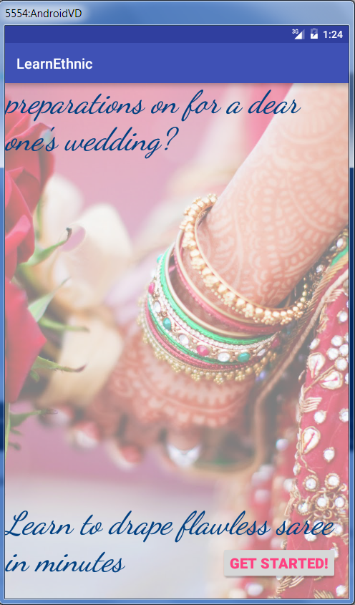

1. Get a bunch of options for your preferred ethnicity  
   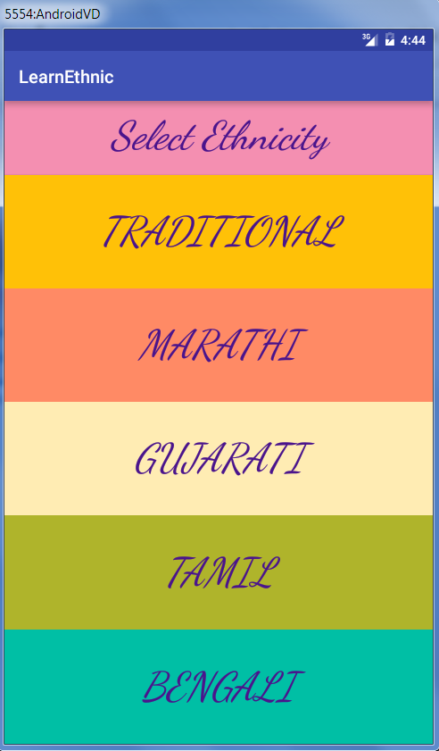
2. Select any one to know a brief background and comprehensive step by step explanation to drape a saree in that ethnicity. For ex:
   1. Tamil  
      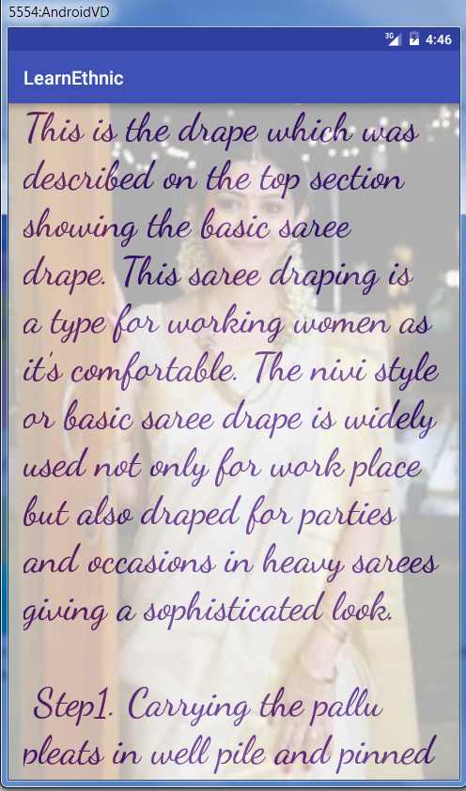
   2. Bengali  
      